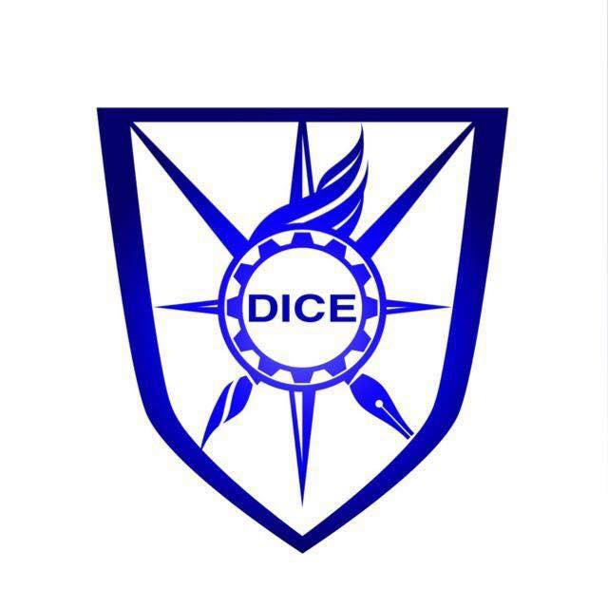

Memorandum of Understanding
between
< Institute Name>
and
DICE Foundation Inc.

- Parties: This Agreement is made and entered into by and between the DICE Foundation Inc., 8607 Forestview drive, Canton MI, USA, and < Institute Name> – Pakistan.

- DICE Foundation (www.dicefoundation.org) is a non-profit, tax-exempt organization, registered in Michigan, USA, under id number 71303A.

- DICE - The term DICE stands for Distinguished Innovations, Collaboration and Entrepreneurship (previously Digital Innovation Competition & Exhibition). The main objective of DICE program is to foster innovation and entrepreneurship culture in the country and use Innovation as a tool to generate wealth for the nation.

- Purpose of Agreement: < Institute Name> has agreed to establish DICE Institute-Level Innovation Platform (IIP) at < Institute Name>, and to host an annual DICE – Institute-Level Innovation Platform (< Institute Name> DICE – IIP), starting 20xx, to promote culture of innovation and entrepreneurship within the institute. The purpose of this agreement is to define the terms and conditions which < Institute Name> and DICE Foundation will abide by in order to establish and operate DICE – IIP, on a long term and sustainable basis.

Following are the terms and the conditions of the Agreement.

Terms and Conditions:

- < Institute Name> will establish DICE Institute-Level Innovation Platform starting in 20xx. The platform will be jointly run by and involve participation from < Institute Name> student society, faculty in charge), industry advisor(s), Office of Research, Innovation and Commercialization (ORIC), and DICE Foundation USA.
- < Institute Name> DICE Institute-Level Innovation Platform (IIP) will conduct an annual competition within the university, at a date mutually agreed upon by both < Institute Name> and DICE Foundation.
- Platform will run promotional campaigns for the event and will actively involve and solicit participation from all departments and faculty within the institute.
- Platform will actively mobilize and solicit participation from industries, leveraging the expertise and network of the platform industry advisor(s).
- DICE Foundation will provide framework (i.e. planning document) for conducting annual DICE IIP event.
- DICE Foundation will provide funds for DICE IIP event prizes for upto a maximum of Rs. 75,000. In addition, DICE Foundation will provide maximum of Rs. 25,000 for final award ceremony arrangements and maximum of Rs. 25,000 for chapter expenses throughout the year.
- Funds for any additional chapter expenses will need to be raised by chapter through industry sponsorships and/or from ORIC.
- DICE Foundation will lend its assistance to the platform for making selected innovations implementation and commercial ready through existing DICE Foundation focused initiatives such as DICE Automotive, DICE energy, Water etc. Platform will monitor ongoing progress.
- Platform will also lend its assistance to other DICE events in the region as and when necessary.
- Platform will arrange talks/online webinars and workshops from industry and expatriate experts throughout the year.
- Platform will be responsible for developing and maintaining DICE IIP website, social media efforts (including facebook, twitter etc.), and soliciting media coverage. The platform will also serve a repository of past events information, member subscription lists and materials such as videos and pictures, including information of industry meetings, webinars etc.
- DICE Foundation will provide administrative and technical capability on the DICE Innovation Portal for IIP to manage the incoming platform submissions and memberships. IIP will still be responsible for developing and maintaining its own website separately for purposes mentioned above.
- IIP will track projects being submitted and ensure that projects being submitted are across a variety of disciplines/fields, and not just being limited to one discipline/field. It is the responsibility of IIP to adjust solicitation methods to target participation from diverse fields while submissions are ongoing.
- IIP should also train incoming student members for a recommended period of 3 months so that transitions between incoming and outgoing student bodies is smooth.
- Platform will actively promote and launch DICE Innovation Portal (http://www.diceinnovationportal.com) within the institute.
- All terms and conditions apply to all campuses of < Institute Name>.

Signatures

In witness whereof, the parties to this Agreement through their duly authorized representatives have executed this Agreement on the days and dates set out below, and certify that they have read, understood, and agreed to the terms and conditions of this Agreement as set forth herein. This agreement will remain effective till agreed and amended mutually.

The effective date of this Agreement is the date of the signature last affixed to this page.

Party 1
< Institute Name>

Name and title of Party 1 Representative

Signature Date

Party 2
DICE Foundation Inc.

Name and title of Party 2 Representative
Mr. Ubaid ur Rehman
Chair, DICE Institute-Level Innovation Platform
DICE Foundation USA

Signature Date

